**CAVENDISH UNIVERSITY ZAMBIA**

**ASSIGNMENT BRIEF AND FEEDBACK FORM**

**STUDENT NUMBER: _ _104-383__ ____**

JULY

2022

**INTAKE**

**ONE/TWO YEAR**

**LECTURER:**

Henry Sinkala

Principles of programming in C COM213

**SUBJECT:**

**ASSIGNMENT NO. 0`**

23rd August, 2023

**DATE HANDED OUT:**

**DATE DUE IN: 20th October,2023**

DAY

**DAY/EVE/DL**

**ASSIGNMENT BRIEF**

GIVEN SHOULD BE IN THIS BOX

In this article I answered four questions as follows;

QUESTION 1

Write a program that calculates and displays the weekly salary for employee who earns

$20 an hour on 30 regular working hours, and earns time and half (wages * 1.5) for over

time worked:

Required:

Prompt the User to only enter the number of hours worked.

QUESTION 2

Write a program (Financial application: future investment) that reads (prompts) in investment

amount, annual interest rate, and number of years to invest, and displays the future

investment values from year1…. YearT; using the following formula:

[Pt = Po (1+r)t

] where; Amount = principle * math.pow (1.0 + rate, year)

QUESTION 3

Write a program ( ZAMTEL Menu) to simulate the MTN Menu using the Unstructured

Supplementary Service Data (USSD) of *117#.

The system should prompts the user to enter a value which will correspond to the

required functionalities.

(Kindly take time to study the CURRENT ZAMTEL USSD MENU *117#

quick codes)

QUESTION 4

Create a program with basic functionalities of a Simple Scientific Calculator.

**STUDENT INSTRUCTIONS:**

1. This form must be attached to the front of your assignment
2. The assignment must be handed in without fail by the submission date (see assessment schedule for your course)
3. Ensure that the submission form is date stamped by the reception staff when you hand it in
4. Late submission will not be entertained unless with prior agreement with the subject tutor
5. All assessable assignments **must** be word processed

**ASSIGNMENT GUIDANCE**

This assignment is intended to assess the student’s knowledge in all of the following areas. However, greater emphasis should be given to those items marked with a

(Tutor: - please tick as applicable)

|  |  |
| --- | --- |
| **ASSESSABLE SKILLS** | **Please Tick.** |
| **Good and adequate interpretation of the questions** |  |
|  |  |
| **Knowledge and application of the relevant theories** |  |
|  |  |
| **Use of relevant and practical examples to back up theories** |  |
|  |  |
| **Ability to transfer and relate subject topics to each other** |  |
|  |  |
| **Application or use of appropriate models** |  |
|  |  |
| **Evidence of library research** |  |
|  |  |
| **Knowledge of theories** |  |
|  |  |
| **Written Business English communication skills** |  |
|  |  |
| **Use of visual (graphs) communications** |  |
|  |  |
| **Self Assessed ‘time management’** |  |
|  |  |
| **Evidence of field research** |  |
|  |  |
|  |  |
| Tutor’s | Mark Contribution |

MARKS

(Administration only[1]*)

LECTURERS FEEDBACK:

Table of Contents

1

**DAY/EVE/DL** 1

**ASSIGNMENT BRIEF** 1

QUESTION 01. 4

QUESTION 02. 6

QUESTION 03. 8

QUESTION 04. 21

References 29

# QUESTION 01.

This question was answered using Python programing language Visual Studio Code.

The program starts with prompting the user to input the number of hours worked in a week and handles any possible errors.

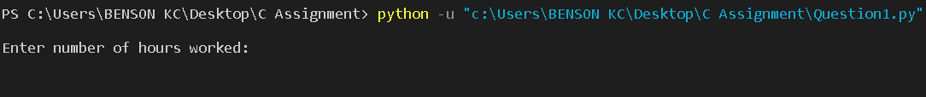

If the user enters a valid number of hours in a week and the minimum to get paid (10 hours).



The program then proceeds to calculate the base weekly salary using the formula (base weekly salary = 20 * 30).

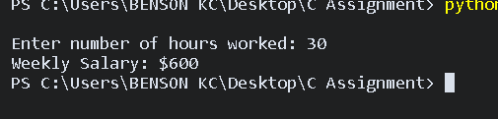

Then the program continues to calculate the overtime hours to use in the calculation for overtime using the formula (overtime hours = user input - 30). If the user input is greater than 30 that’s when this formula applies.

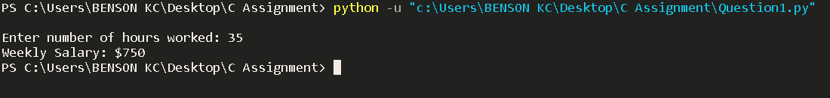

The program then calculates the weeks’ pay based on the user input using the formula (week’s pay = (overtime hours * 30) + base weekly salary) and displays the result to the screen. Else if the user input is not valid the program will display an error message saying "The number of hours entered is invalid. There are only 168 hours in a week."

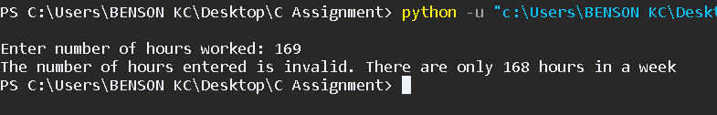

If the user input is not a positive integer the program will display an error message” You have entered invalid input” Then the program will terminate.

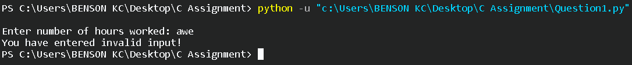

# QUESTION 02.

This question was answered using Python programing language in Visual Studio Code.

The program starts with prompting the user to enter the investment amount.

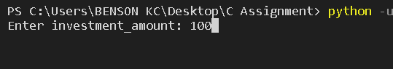

If the investment amount entered is valid, the program then proceeds to prompt the user to enter Annual interest rate.

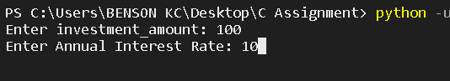

If the user input is valid, the program goes on to prompt the user to enter the number of years to invest.

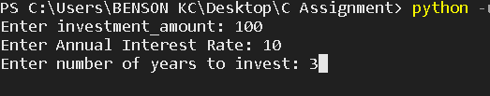

The program goes on to calculate the future investment using the formula;

[Pt = Po (1+r) t] where; Amount = principle * math. Pow (1.0 + rate, year)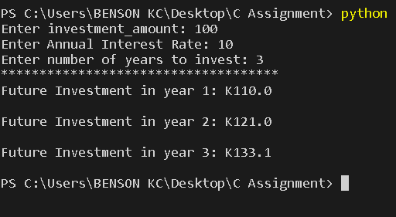

Else, if the input is not valid or less than 1 at any stage the program will display an error message “No investment made!” to the screen and terminate.

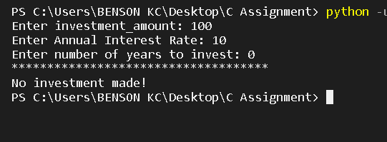

# QUESTION 03.

This question was answered using C programing language Visual Studio Code.

To use the USSD code, the program will first prompt the user to generate a mobile money pin.

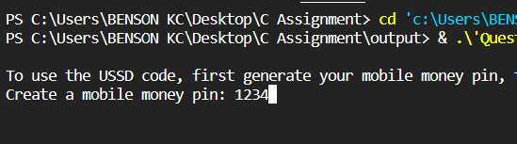

Then the program proceeds to prompt the user to enter their preferred mobile money account balance

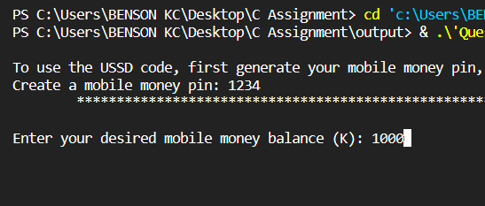

The program will then prompt the user to enter a talk-time balance to purchase any of the packages.

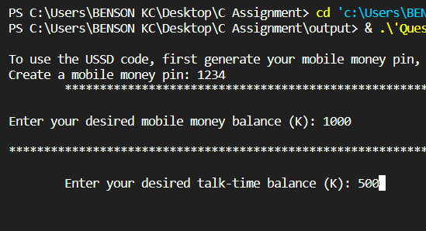

The program will now prompt the user to enter the valid USSD code that will activate the packages.

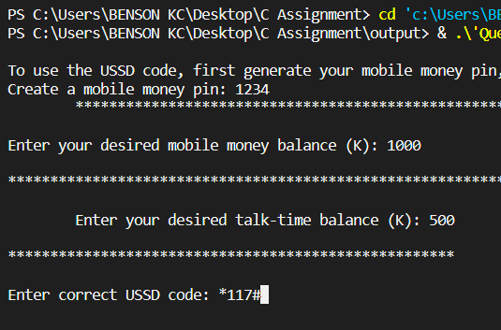

If a valid USSD code has been entered, the program will display the options of the Zamtel package on the screen.

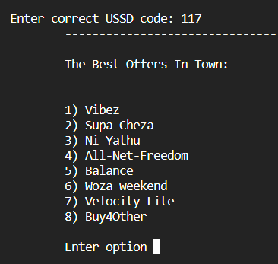

Else if the user input is invalid the program will display the error message

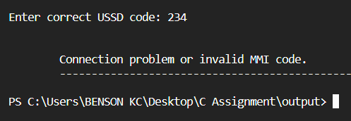

If the user selects the first option, the program will go on to display the option under Vibez.

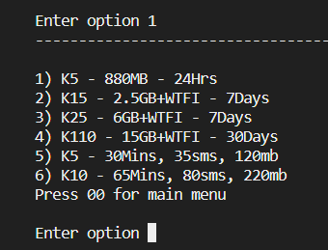

The program will prompt the user to select the package of their choice from the ones displayed on screen, and if the user selects option one the program will go on to display a question to the user, asking the user to make a choice “Are you sure you want to subscribe to K5 - 880MB for 24Hrs?”

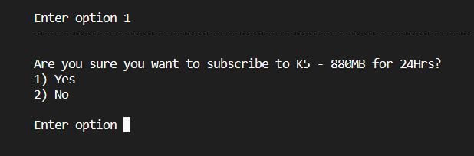

If the user decides to go ahead, the program will ask them their preferred payment method.

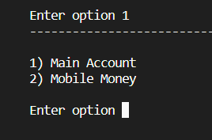

If the user's talk-time balance is greater than or equal to the price of the package, the program proceeds to deduct from their total balance and then display a success message and terminate the program. Otherwise, the program will display the 'insufficient funds' message and terminate the program.

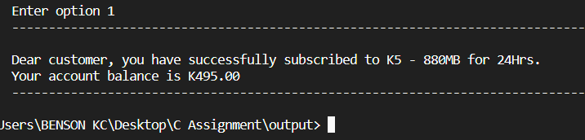

If the user selects to start with option two (2) from the main menu, the program will display the options under Supa Cheza.

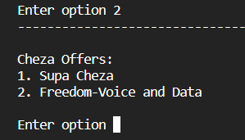

If the user selects option one, the program will display the supa cheza options on the screen,

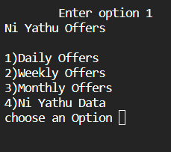

If the user selects option 2 for weekly offers, the program proceeds to display the options prompting the user to choose another option.

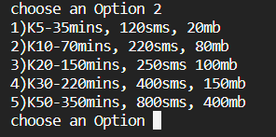

If the user selects the option of their choice, the program will ask them if they are sure they want to buy that package, then the program will prompt the user to choose a payment method of their choice.

If the user's talk-time balance is greater than or equal to the price of the package, the program proceeds to deduct from their total balance and then display a success message and terminate the program. Otherwise, the program will display the 'insufficient funds' message and terminate the program.

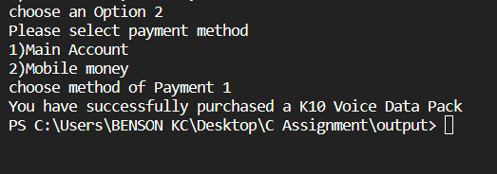

In the case were the user selects option three (3) from the main menu, the program will display the Ni Yathu options.

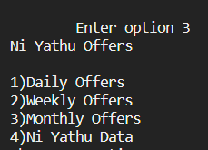

If the user selects the option of their choice, the program will ask them if they are sure they want to buy that package, then the program will prompt the user to choose a payment method of their choice.

If the user's talk-time balance is greater than or equal to the price of the package, the program proceeds to deduct from their total balance and then display a success message and terminate the program. Otherwise, the program will display the 'insufficient funds' message and terminate the program.

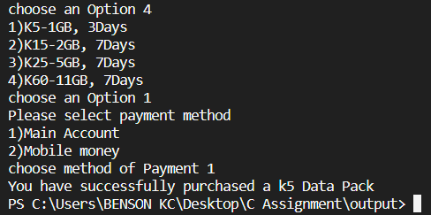

If the user selects to start with option four (4) from the main menu, the program will display the options under All-Net-Freedom on the screen.

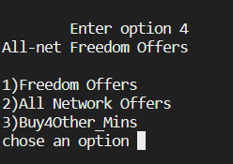

If the user selects the option of their choice, the program will ask them if they are sure they want to buy that package, then the program will prompt the user to choose a payment method of their choice.

If the user's talk-time balance is greater than or equal to the price of the package, the program proceeds to deduct from their total balance and then display a success message and terminate the program. Otherwise, the program will display the 'insufficient funds' message and terminate the program.

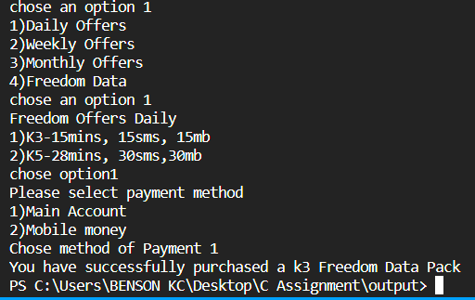

If the user selects to start with option five (5) from the main menu, the program will display the options under Balance. prompt the user to choose the account they want to check the balance and finally display the balance on the screen and terminate the program.

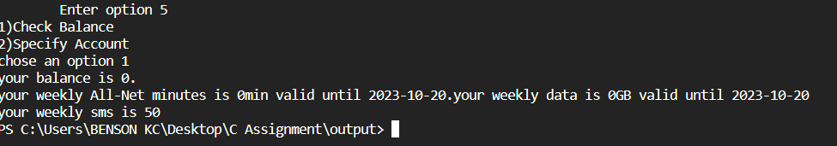

If the user selects to start with option six (6) from the main menu, the program will display the options under Woza Weekend.

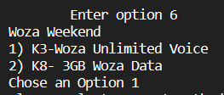

The program will prompt the user to select the option of their choice from the ones displayed on the screen.

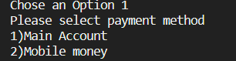

The program will proceed to ask the user to select a payment method, and ask if the user to enter the mobile money pin to continue. Finally, If the user's talk-time balance is greater than or equal to the price of the package, the program proceeds to deduct from their total balance and then display a success message and terminate the program. Otherwise, the program will display the 'insufficient funds' message and terminate the program.

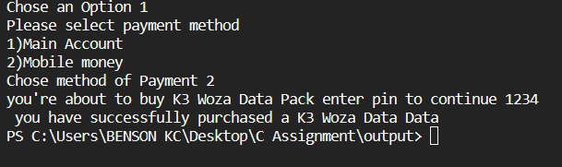

If the user selects to start with option seven (7) from the main menu, the program will display the options under Velocity Lite.

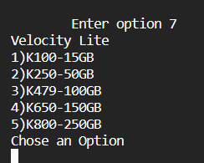

Then, the program will prompt the user to choose an option of their choice and display the options under the chosen option.

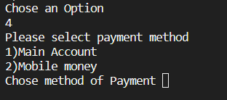

The program proceeds to prompt the user to choose a payment method, If the user's talk-time balance is greater than or equal to the price of the package, the program proceeds to deduct from their total balance and then display a success message and terminate the program. Otherwise, the program will display the 'insufficient funds' message and terminate the program.

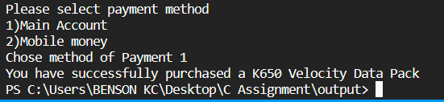

If the user selects to start with option eight (8) from the main menu, the program will display the options under Buy4Others. The program carries on to prompt the user to enter receiving phone number of code (+26095*******) and display a message “Your transaction is in progress. Please wait!”

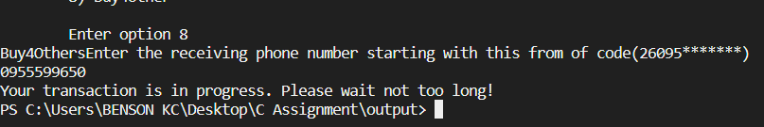

In case the user input is not valid at any stage, the program will display an error message on the screen saying “Invalid input” and terminate the program.

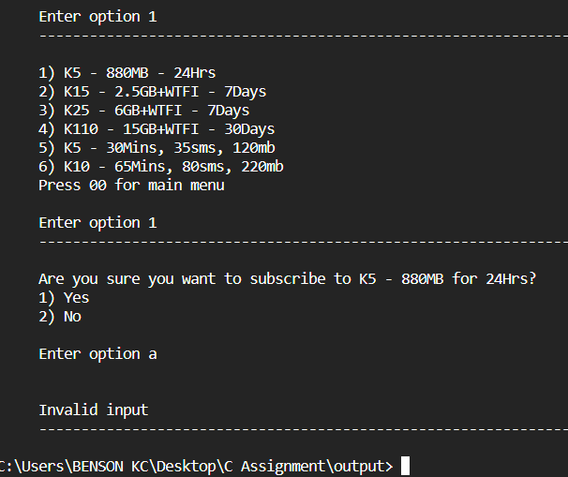

In a case where the user’s balance is less than the selected option, the program will display an error message saying” You cannot buy offer/package due to insufficient funds in your account” and terminate the program.

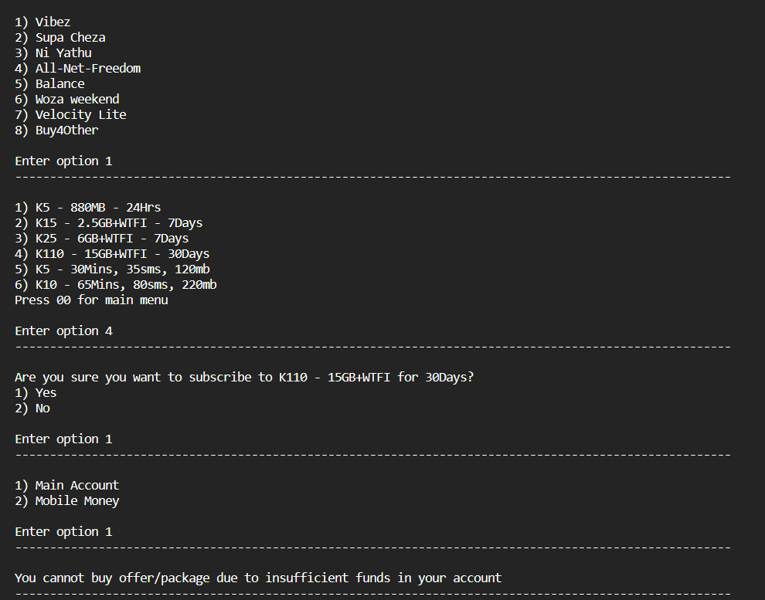

# QUESTION 04.

This question was answered using C programing language Visual Studio Code.

The program starts with prompting the user to select an option from the displayed options on the screen.

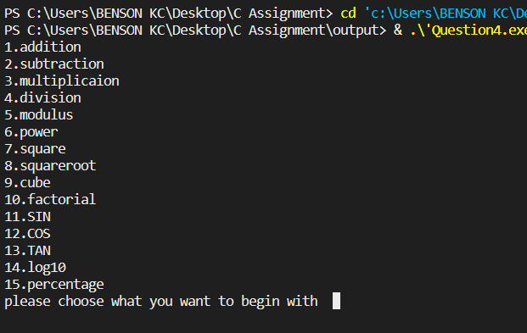

If the user decides to begin with option one (Addition), the program will prompt the user to enter two numbers (x and y) of their choice and if the input is valid the program will proceed to add the two numbers, display the answer on the screen and terminate the program.

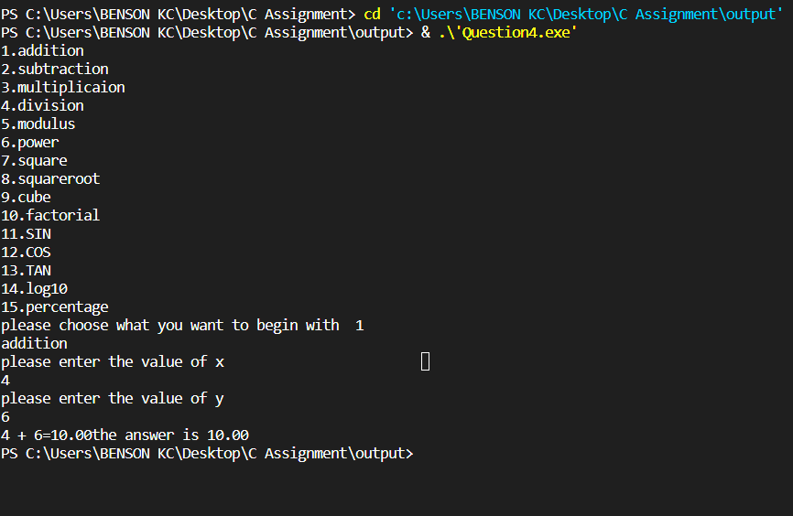

In the case where the user chooses to start with option two (Subtraction), the program will prompt the user to enter two numbers (x and y) of their choice and if the input is valid the program will proceed to subtract the two numbers, display the result on the screen and terminate the program.

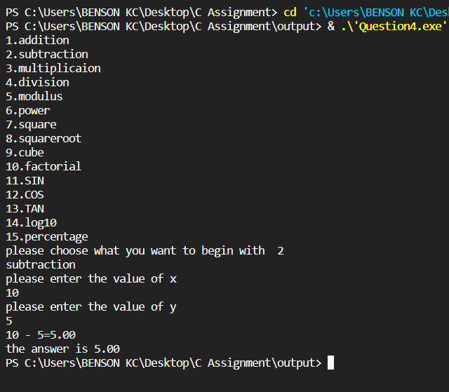

In the case where the user chooses to start with option three (Multiplication), the program will prompt the user to enter two numbers (x and y) of their choice and if the input is valid the program will proceed to multiply the two numbers, display the result on the screen and terminate the program.

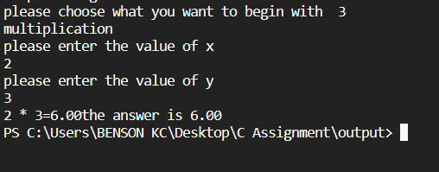

In the case where the user chooses to start with option four (Division), the program will prompt the user to enter two numbers (x and y) of their choice and if the input is valid the program will proceed to divide the two numbers, display the result on the screen and terminate the program.

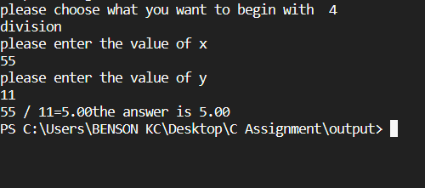

In the case where the user chooses to start with option five (Modulus), the program will prompt the user to enter two numbers (a and b) of their choice and if the input is valid the program will proceed to calculate the modulus of the two numbers, display the result on the screen and terminate the program.

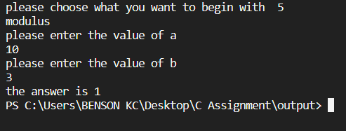

In the case where the user chooses to start with option six (Power), the program will prompt the user to enter two numbers one as the base number and the other as the power (x and y) of their choice. If the input is valid the program will proceed to calculate the two numbers, display the result on the screen and terminate the program.

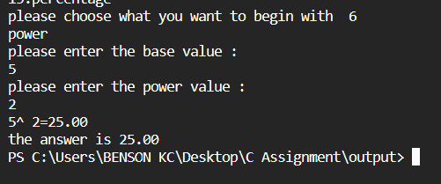

In the case where the user chooses to start with option seven (square), the program will prompt the user to enter any number (x) of their choice. If the input is valid the program will proceed to square the number, display the result on the screen and terminate the program.

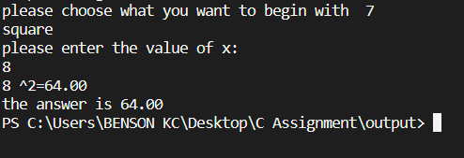

In the case where the user chooses to start with option eight (square root), the program will prompt the user to enter any number (x) of their choice. If the input is valid the program will proceed to square rooted the number, display the result on the screen and terminate the program.

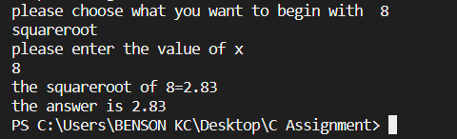

In the case where the user chooses to start with option nine (cube), the program will prompt the user to enter any number (x) of their choice. If the input is valid the program will proceed to cube the number, display the result on the screen and terminate the program.

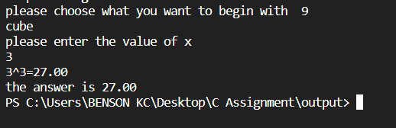

In the case where the user chooses to start with option ten (factorial), the program will prompt the user to enter any number (x) of their choice. If the input is valid the program will proceed to calculate the factorial of the number, display the result on the screen and terminate the program.

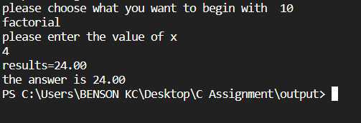

In the case where the user chooses to start with option eleven (SIN), the program will prompt the user to enter any number (x) of their choice. If the input is valid the program will proceed to calculate the SIN of the number, display the result on the screen and terminate the program.

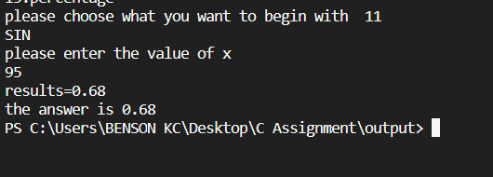

In the case where the user chooses to start with option twelve (COS), the program will prompt the user to enter any number (x) of their choice. If the input is valid the program will proceed to calculate the COS of the number, display the result on the screen and terminate the program.

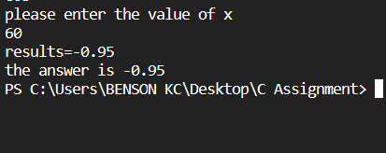

In the case where the user chooses to start with option thirteen (TAN), the program will prompt the user to enter any number (x) of their choice. If the input is valid the program will proceed to calculate the TAN of the number, display the result on the screen and terminate the program.

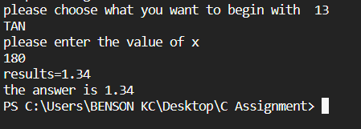

In the case where the user chooses to start with option fourteen (Log10), the program will prompt the user to enter any number (x) of their choice. If the input is valid the program will proceed to calculate the Log10 of the number, display the result on the screen and terminate the program.

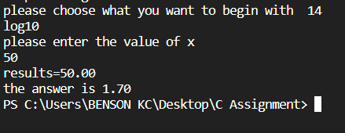

In the case where the user chooses to start with option fifteen (percentage), the program will prompt the user to enter any number (x) of their choice. If the input is valid the program will proceed to calculate the percentage of the number, display the result on the screen and terminate the program.

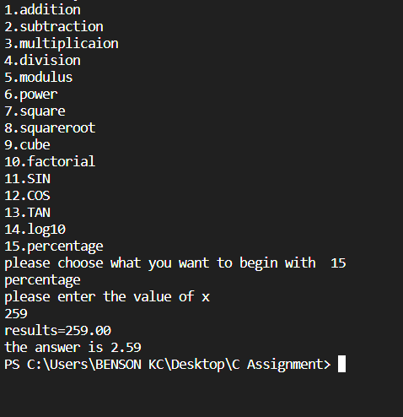

# References

[*Raymond, Eric S.*](https://en.wikipedia.org/wiki/Eric_S._Raymond)*(October 11, 1996).*[*The New Hacker's Dictionary*](https://books.google.com/books?id=g80P_4v4QbIC&pg=PA432)*(3rd ed.). MIT Press. p. 432.*[*ISBN*](https://en.wikipedia.org/wiki/ISBN_(identifier))[*978-0-262-68092-9*](https://en.wikipedia.org/wiki/Special:BookSources/978-0-262-68092-9)*. Retrieved August 5, 2012.*

*"C manual pages".*[*FreeBSD Miscellaneous Information Manual*](https://nxmnpg.lemoda.net/7/c78)*(FreeBSD 13.0 ed.). May 30, 2011.*[*Archived*](https://web.archive.org/web/20210121024455/https:/nxmnpg.lemoda.net/7/c78)*from the original on January 21, 2021. Retrieved January 15, 2021.* [[1]](https://www.freebsd.org/cgi/man.cgi?query=c78&apropos=0&sektion=0&manpath=FreeBSD+9-current&arch=default&format=html) [Archived](https://web.archive.org/web/20210121033654/https:/www.freebsd.org/cgi/man.cgi?query=c78&apropos=0&sektion=0&manpath=FreeBSD+9-current&arch=default&format=html) January 21, 2021, at the [Wayback Machine](https://en.wikipedia.org/wiki/Wayback_Machine)

[Plauger, P.J.](https://en.wikipedia.org/wiki/P._J._Plauger) (1992). *The Standard C Library* (1 ed.). Prentice Hall. [ISBN](https://en.wikipedia.org/wiki/ISBN_(identifier)) [978-0131315099](https://en.wikipedia.org/wiki/Special:BookSources/978-0131315099).

1.